Smart Sorting: Transfer Learning for Identifying Rotten Fruits and Vegetables

TEAM ID : LTVIP2026TMIDS66114
Team Members:

MEMBER | RESPONSIBILITY
1.Alle Sreeja | Project planning
2.Nidamanuri Sri Vardhini | Project Designing
3. Shaik Hidayatulla | Project Testing
4. Lingala Pujitha | Requirement gathering
5. Alle Sreeja | Project Implementation

1.Introduction
Project Title:
Smart Sorting: Transfer Learning for Identifying Rotten Fruits and Vegetables
2. Project Overview
Purpose:
The purpose of the Smart Sorting: Transfer Learning for Identifying Rotten Fruits and Vegetables project is to design and develop an automated system that can accurately identify and classify fruits and vegetables as fresh or rotten using image processing and deep learning techniques.
The project aims to replace manual inspection methods, which are time-consuming and prone to human error, with a reliable and efficient machine learning–based solution. By using transfer learning, the system achieves high accuracy even with limited training data, making it suitable for real-world applications such as food processing industries, supermarkets, and smart homes.
This project also focuses on reducing food waste, improving quality control, and supporting modern intelligent systems in the agricultural and food supply chain.
Features of the Project
- Automated detection of fresh and rotten fruits and vegetables using image classification.
- Utilization of transfer learning techniques to improve accuracy and reduce training time.
- Image-based input system that accepts images captured from cameras or uploaded by users.
- Support for multiple classes of fruits and vegetables, including both fresh and rotten categories.
- High accuracy and reliable performance through effective preprocessing and model evaluation.
- User-friendly interface that displays clear classification results.
- Scalable system design that can be extended to include more fruit and vegetable categories in the future.
- Helps in reducing food waste, labor cost, and manual effort in quality inspection processes.

3. Architecture

Scenario:
Ravi, a quality control supervisor in a food processing unit, faces challenges in manually sorting large quantities of fruits and vegetables to identify rotten produce. To improve efficiency and accuracy, the organization implements a Smart Sorting system based on transfer learning to automatically detect fresh and rotten fruits and vegetables

User Access and System Initialization:

Ravi accesses the Smart Sorting System through a web-based application and logs in using authorized credentials. After successful login, he is redirected to the dashboard, where he can upload images or enable a camera feed for inspection. The system initializes the trained deep learning model for further processing.

Image Upload and Capture:

Ravi uploads images of fruits and vegetables or allows the system to capture images in real time using a camera installed along the sorting line. The captured images are forwarded to the image preprocessing module.

Image Preprocessing and Feature Extraction:

The system preprocesses the images by resizing, normalization, and noise reduction. These processed images are passed to a transfer learning–based convolutional neural network, which extracts important features such as color, texture, and surface defects.

Classification and Prediction:

Using the extracted features, the trained model classifies each fruit or vegetable as either fresh or rotten. The prediction results are generated quickly with high accuracy.

Result Display and Output:

The classification results are displayed on the user interface. Rotten fruits and vegetables are clearly identified, enabling quick decision-making. The system can also be integrated with sorting mechanisms to separate rotten produce automatically.

System Monitoring and Management:

The system administrator monitors the overall performance of the Smart Sorting System. The admin manages datasets, updates the model when required, and ensures smooth system operation.

Quality Control and Decision Support:

Based on the classification results, Ravi takes appropriate action such as removing or separating rotten produce. The system supports quality control processes, reduces food waste, and improves operational efficiency.

Solution Architecture
To provide an intelligent, accurate, and scalable image classification system that automatically identifies rotten and fresh fruits and vegetables using transfer learning and deep learning techniques. Effortless Appointment Booking
- Automated image upload and processing system
- Image preprocessing for feature extraction
- Transfer learning using pre-trained convolutional neural network models
- Accurate classification of fruits and vegetables as fresh or rotten
- Fast and reliable prediction output
- Scalable system that can be integrated with industrial automation and smart devices
- User-friendly interface for easy interaction

Example - Solution Architecture Diagram:
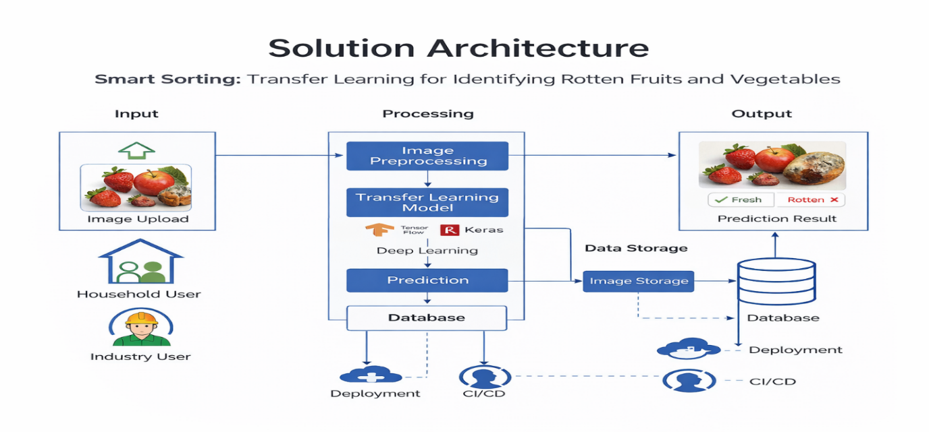
4. Setup Instructions
PRE-REQUISITES:
The following software and tools are required to develop and run the Smart Sorting System using Machine Learning.

Python:
Python is a high-level, interpreted programming language widely used for machine learning, data processing, and backend development. In this project, Python is used to train the machine learning model and to develop the backend server.
• Install Python version 3.8 or above
• Download link: https://www.python.org/downloads/
• During installation, ensure that the option “Add Python to PATH” is selected

Virtual Environment (Optional but Recommended):
A virtual environment is used to manage project-specific dependencies and to avoid conflicts with system-installed libraries.
• Create a virtual environment using Python
• Activate the virtual environment before installing dependencies

Flask:
Flask is a lightweight web framework used to build the backend of the Smart Sorting application. It handles routing, server requests, and rendering of HTML pages.
• Flask is installed using Python’s package manager (pip)

TensorFlow and TensorFlow Lite:
TensorFlow is an open-source machine learning framework used to build and train the image classification model. TensorFlow Lite is used to deploy the trained model efficiently for inference.
• TensorFlow is required to load and run the trained TFLite model

OpenCV:
OpenCV is an open-source computer vision library used for image processing and camera access. It is used to capture waste images for classification.
• OpenCV is required for camera handling and image preprocessing

NumPy:
NumPy is a numerical computing library used for handling arrays and mathematical operations on image data.
• NumPy is required for data processing and model input preparation

HTML, CSS, and JavaScript:
Basic knowledge of front-end technologies is required to build the user interface of the application.
• HTML is used for structuring the web pages
• CSS is used for styling the user interface
• JavaScript is used for client-side interaction

Development Environment:
A suitable code editor or Integrated Development Environment (IDE) is required for writing and managing the project code.
• Visual Studio Code (Recommended)
• Download link: https://code.visualstudio.com/download

Version Control:
Git is used for version control to track changes and manage the project repository.
• Git download link: https://git-scm.com/downloads

Steps to Run the Smart Sorting Project (Downloaded from GitHub)
Step 1: Clone the Repository
• Open the terminal or command prompt
• Navigate to the directory where you want to store the project
• Clone the repository using the Git clone command

Step 2: Navigate to the Project Directory
• Open the project folder
• Navigate to the “Project” directory where the main application files are located

Step 3: Create and Activate Virtual Environment
• Create a virtual environment using Python
• Activate the virtual environment before installing dependencies

Step 4: Install Required Dependencies
• Install Flask, TensorFlow, NumPy, and OpenCV using pip

Step 5: Verify Project Folder Structure
Ensure the project follows the correct structure:
Project
– app.py
– model
– smart_sorting_model.tflite
– templates
– index.html
– static
– style.css

Step 6: Run the Application
• Execute the application using Python
• The Flask server will start locally

Step 7: Access the Application
• Open a web browser
• Navigate to: http://127.0.0.1:5000/
• The Smart Sorting web application interface will be displayed

Optional: Model Training
• If a dataset is available and retraining is required, execute the model training file
• Training requires a properly structured dataset directory

Conclusion:
You have successfully installed and configured the Smart Sorting System using Machine Learning on your local machine. The application is now

5.PROJECT STRUCTURE:

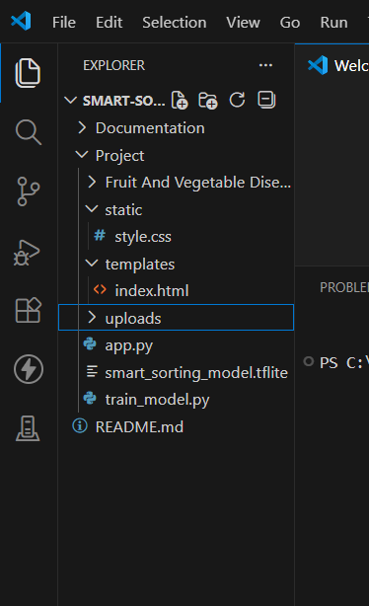
6.APPLICATION FLOW
Smart Sorting: Transfer Learning for Identifying Rotten Fruits and Vegetables

1. User / Operator
Role:
Upload or capture images of fruits and vegetables, view classification results, and monitor quality inspection.
Flow:
- Registration and Login:
- The user creates an account by providing basic details such as username, email, and password.
- The user logs into the Smart Sorting system using registered credentials.
- Image Upload and Capture:
- After login, the user accesses the dashboard.
- The user uploads images of fruits and vegetables or enables a camera feed for real-time image capture.
- Image Processing and Prediction:
- The uploaded or captured images are sent to the preprocessing module.
- The system processes the images and passes them to the trained deep learning model.
- The model predicts whether the fruit or vegetable is fresh or rotten.
- Result Viewing:
- The classification result is displayed on the dashboard.
- The user can view clear output indicating fresh or rotten produce.
- Profile Management:
- The user can manage personal details and view previous prediction records if available.

2. System (Smart Sorting Engine)
Role:
Process images, perform classification using transfer learning, and generate accurate results.
Flow:
- Image Preprocessing:
- Resize, normalize, and enhance input images for consistency.
- Prepare images for feature extraction.
- Feature Extraction and Classification:
- Use a pre-trained convolutional neural network model to extract features.
- Classify fruits and vegetables as fresh or rotten using transfer learning.
- Prediction Output:
- Generate fast and reliable prediction results.
- Send results to the user interface for display.
- Model Performance Monitoring:
- Maintain logs of predictions and system performance.
- Ensure consistent accuracy and efficiency.

3. Admin
Role:
Manage system operations, datasets, and overall performance of the Smart Sorting platform.
Flow:
- System Monitoring and Management:
- Monitor the overall functioning of the Smart Sorting system.
- Ensure smooth processing of image inputs and predictions.
- Dataset and Model Management:
- Manage training datasets used for model development.
- Retrain or update the model when required to improve accuracy.
- User Management:
- Manage user accounts and access permissions.
- Ensure secure and authorized usage of the system.
- System Optimization and Maintenance:
- Improve system performance and scalability.
- Address technical issues and enhance reliability for real-world deployment.

7.User Interface

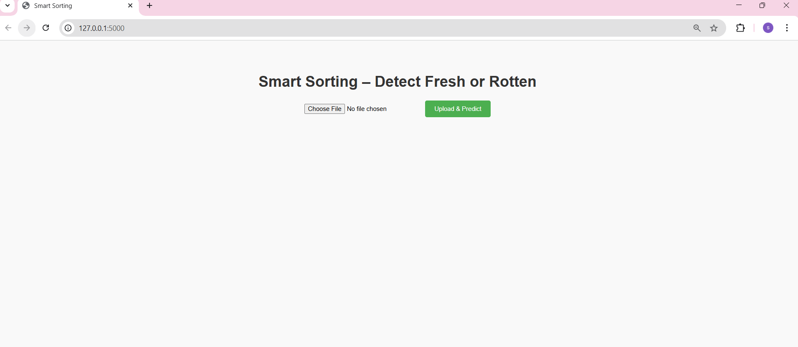
Fig: Interface

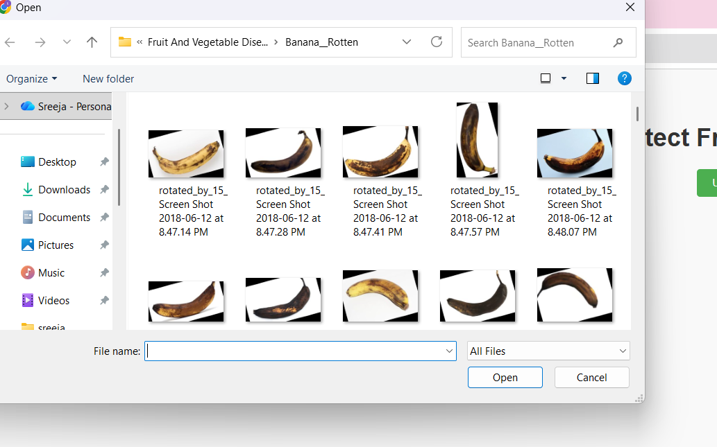
Fig: File Upload

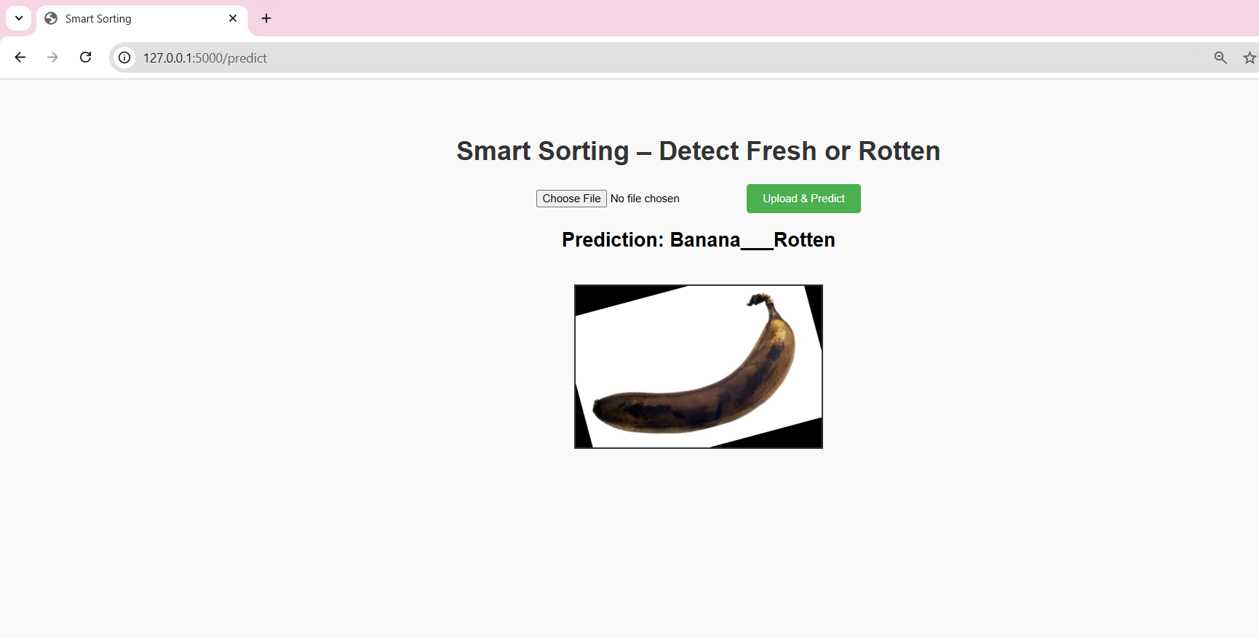
Fig: Banana Detection

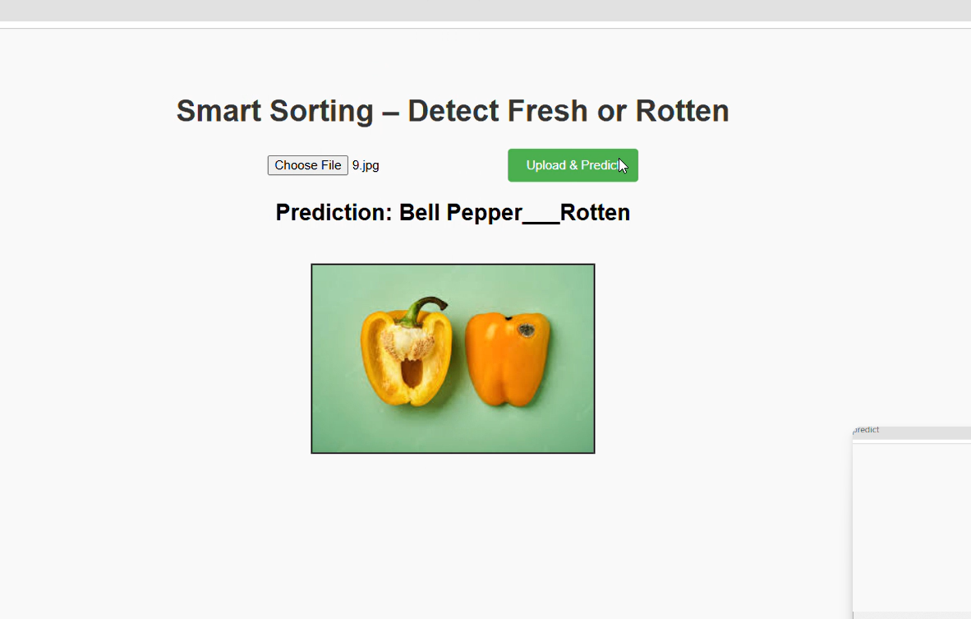
Fig: Rotten Bell Pepper Detection
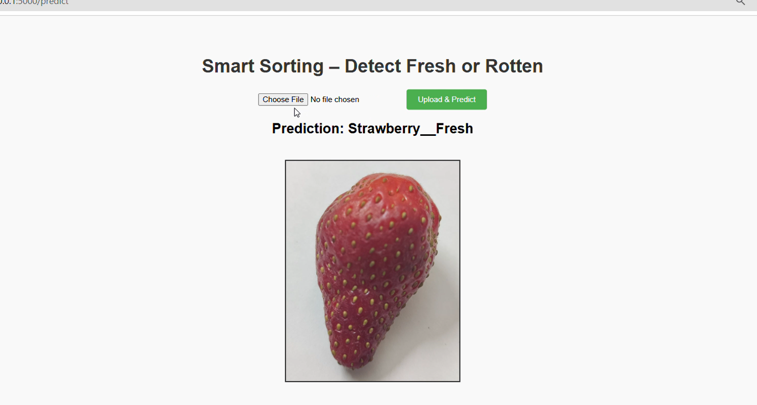
Fig: Fresh Strawberry Detection
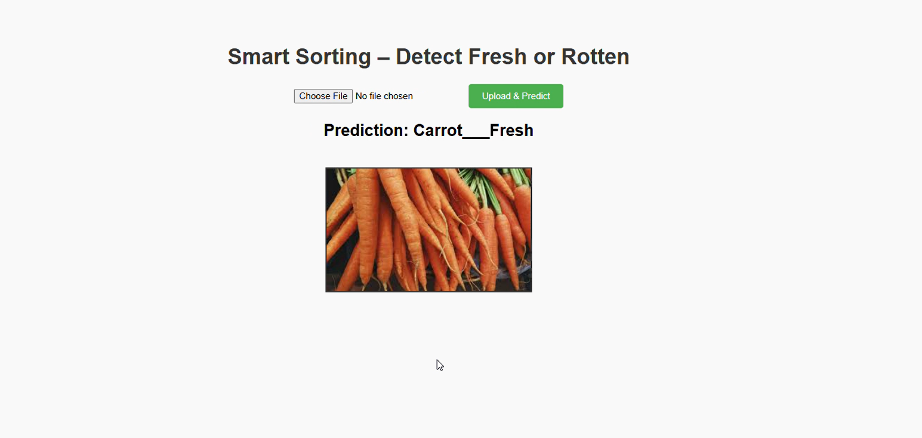
Fig: Fresh carrot Detection

8. Authentication
Users of the Smart Sorting system (operators and administrators) are required to register using a valid email ID and password. During login, the system verifies these credentials to authenticate the user. Upon successful authentication, the system allows secure access to the application and maintains the user session throughout usage.
Authorization:
Each authenticated user is assigned a specific role, such as operator or admin, which determines their access permissions within the system. The system enforces role-based authorization as follows:
• Operators can upload or capture images of fruits and vegetables and view classification results.
• Operators can monitor whether the produce is fresh or rotten through the dashboard.
• Admins can manage users, datasets, and system configurations.
• Admins can update or retrain the deep learning model and monitor system performance.
This role-based authentication and authorization approach ensures secure access, protects system resources, and prevents unauthorized use of system features.

9. Testing Strategy
To ensure the reliability and correctness of the Smart Sorting system, multiple testing strategies are applied.
Unit Testing:
Each individual module of the system is tested independently. For example, image upload, preprocessing functions, and prediction logic are tested separately to verify that each component works correctly on its own.
Integration Testing:
Integration testing is performed to ensure that different system modules work together properly. For instance, testing whether an uploaded image is successfully processed and passed to the deep learning model for prediction.
End-to-End Testing:
End-to-end testing validates the complete workflow of the system. This includes logging into the system, uploading an image, processing it through the model, and displaying the classification result to the user.
Acceptance Testing:
Acceptance testing is carried out from the user’s perspective to ensure the system meets all functional requirements. This testing confirms that the system is easy to use, provides accurate results, and satisfies the overall project objectives.

10.Demo
The demo of the app is available at:
https://drive.google.com/file/d/1KV4oMGH0hlef8us5s-hNu6AZDjNi3uwm/view?usp=sharing

11. Known Issues
Backend (Flask and Deep Learning Model)
• Prediction latency may occur when processing high-resolution images or multiple images at the sametime.
• Some backend errors during image upload or model prediction may not be handled gracefully.
• System performance depends on hardware resources, and low-end systems may experience slower processing.

Frontend (Web Interface)
• The user interface may not render properly on older or unsupported web browsers.
•Layout inconsistencies may occur on small mobile screens and tablets.
• Limited user feedback such as insufficient loading indicators or error messages may affect usability.

Dataset and Model Limitations
• Model accuracy depends on the quality and diversity of the training dataset.
• The system may perform poorly under low-light conditions or with blurred images.
• The system is limited to the predefined fruit and vegetable classes used during training.

Security and Access Control
•Basic email and password authentication may not provide advanced security.
•Role-based access control may not be strictly enforced across all system modules.
• Improper validation of uploaded images may allow unsupported or corrupted files.

12. Future Enhancements
Mobile Optimization
• Develop Android and iOS applications for image capture and result viewing.
• Optimize the user interface for mobile devices using responsive design.
• Integrate real-time alerts and notifications for detecting rotten produce.

Smart Sorting Enhancements
• Implement real-time camera-based detection for conveyor belt automation.
• Expand the dataset to support more fruits and vegetables.
• Integrate automated sorting mechanisms to physically separate rotten produce.

Advanced AI and Analytics
• Use advanced deep learning models to improve classification accuracy.
• Implement analytics dashboards to monitor system performance and accuracy.
• Enable automatic model retraining using newly collected data.

